Copyright (c) 2023 The Regents of the University of Michigan

iGATE software, documentation and test dataset are available for non-commercial academic research and education use only at https://github.com/UmichWenLab/iGATE. Commercial use will require a license – please contact feiwenum@umich.edu for further information.

**Instructions to export a population as a .csv file from FlowJo:**

One .csv file for each population is needed as training data for iGATE_train.

1. Right click on the population.
2. Select “Export/Concatenate Populations”

1. (1) Select “CSV – Scale values” for the format. (2) Under “Destination”, select the output location. (3) Select “Export” to export the file.

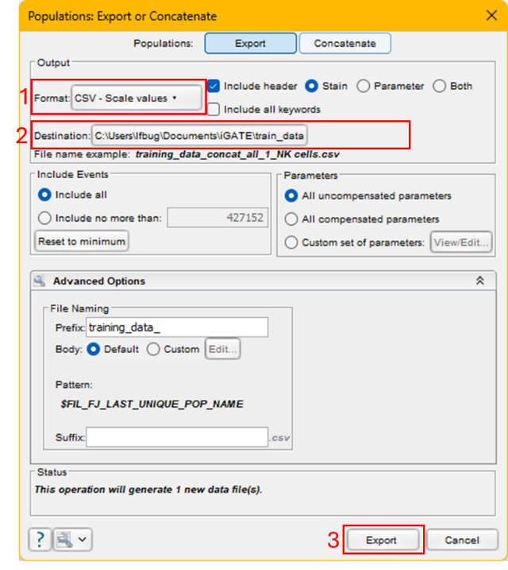

1. Rename the exported files if desired. iGATE automatically names a population according to the name of the corresponding .csv file.

**iGATE installation for macs:**

1. Download the files iGATE_train_mac and iGATE_predict_mac.
2. Run iGATE_train_mac and iGATE_predict_mac to install the two applications. If MATLAB runtime is not installed, MATLAB Runtime installer will be triggered immediately. This is free and allows use of iGATE without a MATLAB license.

**iGATE installation for PCs:**

1. Install MATLAB Runtime (<https://www.mathworks.com/products/compiler/matlab-runtime.html>) version R2023b (23.2). This is free and allows use of iGATE without a MATLAB license.
2. Download the files iGATE_train_pc and iGATE_predict_pc.
3. Run each file to install iGATE_train or iGATE_predict. Follow the installation instructions.

**iGATE instructions**

1. Run iGATE_train. This can be done by double clicking iGATE_train.exe (PC) or iGATE_train.app (mac). Installation will create a new folder named “University of Michigan”, probably located in your “Program Files” (PC) or “Applications” (mac) folder. To find iGATE_train.exe/iGATE_train.app, go to the following folder: University of Michigan 🡪 iGATE_train 🡪 applications.
2. You will be prompted to:
   1. Select all the training .csv files. Each .csv file should contain manually gated cells of a single cell population.

* 1. Select the output folder. You must have writing permissions in this folder.

* 1. Select the channels to use for training. Hold down the ctrl (PC) or command (mac) key to select multiple channels. We used the following channels in our manuscript:
     + CD3
     + CD19
     + TCRgd
     + CD64
     + CD127
     + CD24
     + CD62L
     + CD49b
     + IA/IE
     + IgM
     + Siglec-F
     + CD4
     + CD45R/B220
     + CD103
     + CD206
     + CD8
     + Ly6C
     + CD11c
     + Ly6G
     + CD45
     + CD44
     + CD11b
     + IgD

* 1. Multiple progress bars will appear as the program runs.

1. Upon completion, 5 windows will be open:
   1. The confusion matrix A screenshot of a computer

      Description automatically generated
   2. A plot of validation accuracy vs posterior probability thresholdA screen shot of a computer screen

      Description automatically generated
   3. A plot of frequency of rejected cells vs posterior probability thresholdA screen shot of a computer screen

      Description automatically generated
   4. The output folder

* 1. A message box stating that the training is complete.

1. Additionally, 9 files will be generated in the output folder.
   1. input_needed_for_prediction.m: contains data that will be used with the prediction executable
   2. CellTypesKey.csv: During the prediction step, each cell will be assigned a number that corresponds to a certain cell phenotype. This file lists the numerical values for each cell phenotype.
   3. Accuracy vs Threshold.png: plot of gating accuracy for different threshold values
   4. Accuracy vs Threshold.csv: numerical values for the Accuracy vs Threshold plot
   5. Rejection Frequency vs Threshold: plot of Frequency of Rejected cells for different threshold values
   6. Rejection Frequency vs Threshold.csv: numerical values for the Rejection Frequency vs Threshold plot
   7. Confusion Matrix.png: image of the confusion matrix
   8. Confusion Matrix.csv: numerical values for the confusion matrix
   9. train_channels.csv: lists the channels that were selected by the user for training
2. Run (double click) iGATE_predict.exe/iGATE_predict.app. This file will be found in the following folder: University of Michigan 🡪 iGATE_predict 🡪 applications.
3. You will be prompted to:
   1. Specify the Posterior Probability Threshold. In our study, we found a value of 0.995 to be appropriate. A screenshot of a computer

      Description automatically generated
   2. Select the .csv files with unlabeled cells.

* 1. Select the input_needed_for_prediction.mat file that was output in iGATE_train.

* 1. Select the output folder. You must have writing permissions in this folder.

* 1. Select the channels to use for the predictions. You must select the same channels that were used for training.

* 1. Multiple progress bars will appear as the program runs.

1. Upon completion, 2 windows will open:
   1. The output folder

* 1. A message box stating that the training is complete. A screenshot of a cell type identification message

     Description automatically generated

1. The following files will be generated by the script and are found in the output folder:
   1. Labeled .csv. Each labeled .csv file will have the suffix “_iGATED.csv”. Each file is identical to the unlabeled .csv file except an additional channel has been added to the beginning of the .csv file. This channel is named “CellTypeID” and contains the cell type identifier. Each identifier is an integer that corresponds to a cell type. The list of cell type identifiers and the corresponding cell types can be found in both cell_percents_by_file.csv and cell_counts_by_file.csv which were also generated by iGATE_predict.
   2. cell_percents_by_file.csv: This file contains a list of cells types, the corresponding cell type identifiers, and the percent of each cell type for each labeled file.
   3. cell_counts_by_file.csv: This file contains a list of cells types, the corresponding cell type identifiers, and the counts of each cell type for each labeled file.
   4. predict_channels.csv: Lists the channels that were selected by the user for prediction. These channels should be identical to the ones used for training (listed in train_channels.csv).
2. To analyze a .csv file in FlowJo:
   1. Open FlowJo
   2. Drag .csv files into the FlowJo workspace. They will be automatically converted to .fcs files that can be analyzed in FlowJo.A screenshot of a computer

      Description automatically generated
   3. For each marker, we recommend changing the scale values:
      1. Select “Customize Axis…)

* + 1. Se the axis values to the following: (1) Scale: ArcSinh, Min: -3.16 (lowest value), Max: 12000

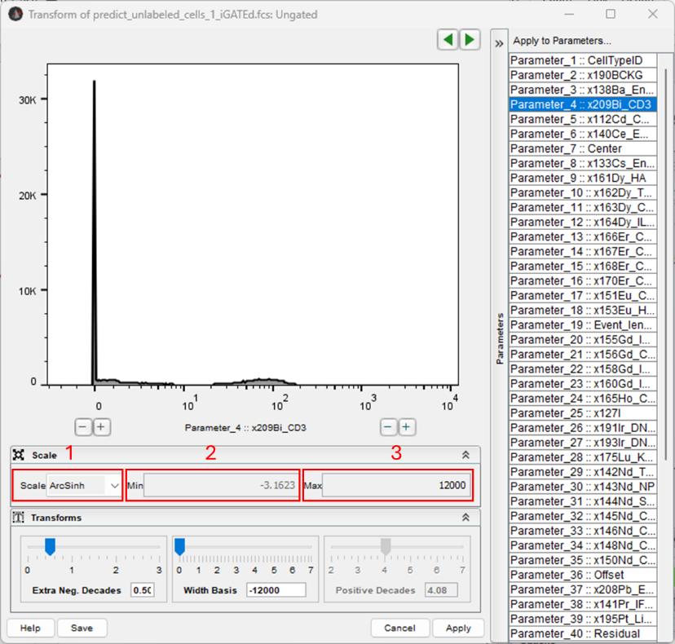

* 1. The .fcs files will appear in the same folders where the .csv files were. A screenshot of a computer

     Description automatically generated